Current SOP for TIP Text Alerts (FY24)
www.Finviz.com
Login with credentials below
Email: info@theinflectionpt.com
Password: XXXX
Check the three scanners for candidates that match the following criteria is this order…
- Hover over the tickers and right click to bring up the best patterns
- Look for market caps in between $100 M and $1B
- Look for volume over 1 M with Average Volume of over 1 M
- Look for high relative volume
- Look for Volume vs. Outstanding shares
- Beware of thinly traded stocks (low vol, erratic movements)
- Look at big picture market trends, does it make sense?
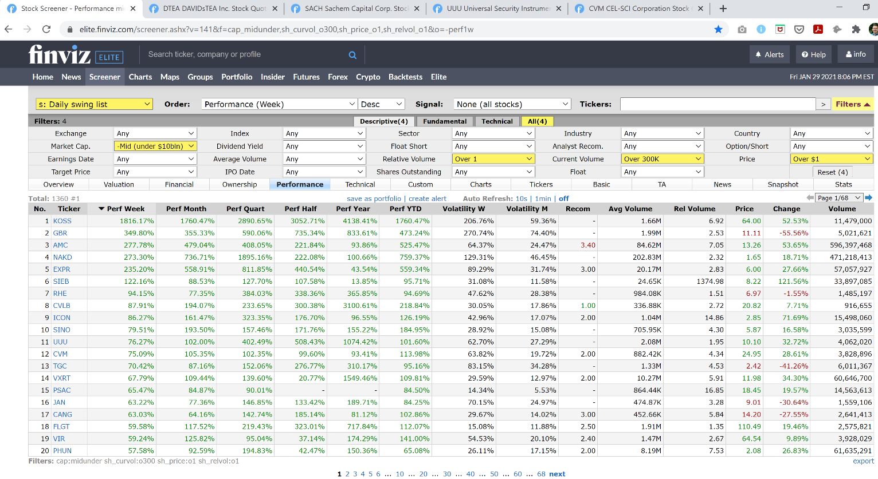

Select five best charts that match all criteria
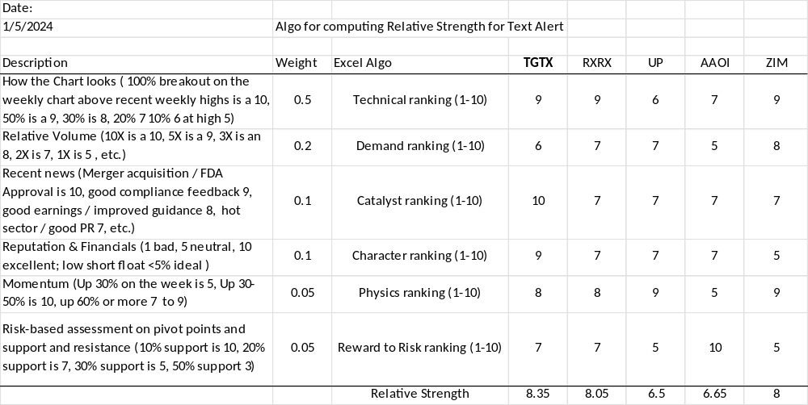
See Excel Algo in SOP folder for built in formulas to compute relative strength. Start with the highest relative strength and run through the ten point checklist:
- Up over 20% at one point in the last week, > 5% volatility < 20%
- Up over 10% or more this week and month
- In the positive Year Over Year / 6 months; uptrend on daily chart
- Volume over 1 Million shares traded today; Over 300K avg vol.
- Catalyst for price move this week or recently; No earning upcoming
- Vetted – No Class Action Lawsuits, good reputation, no recent IPO
- On the charts (not ‘Off the charts’) – NOT up +200% in last week
- High Relative Volume > 1.3
- Good company team and fundamentals
- Low Shares Outstanding (preferably < 200M)

Red flags to be aware of when Trading and Investing in the markets:

Reverse Stock Splits. Take an extra second and do a word search in the company’s news for ‘Reverse’. Reverse Stock Splits are never a good sign. This usually means the company is struggling to maintain minimum de-listing requirements. Avoid these companies.

Repeat news. A company may post the same news over and over again in an attempt to pump the stock price so they can dump the equity while it temporarily spikes.

Company name changes. Not always, but sometimes company’s change names to hide something. I’m all for name changes that inspire and create a better company brand. Just make sure the company didn’t just Reverse Stock Split or have a big claim filed against them.

Company takeovers are generally regarded as positive depending on the takeover valuation. However, volatility usually decreases after a takeover, therefore we tend to ignore takeover action. We also avoid takeover rumors. Be an Independent thinker.

